1. <p content-type="no-indent"> for left align
2. H1: <sec id="s1_5">
3. H2: <sec id="s1_5_1">
4.
<fig id="c1-fig5">
<label>Figure&#xa0;5.</label>
<graphic orientation="portrait" xlink:href="figures/slcs.188.01ver_fig5.svg"/>

5.

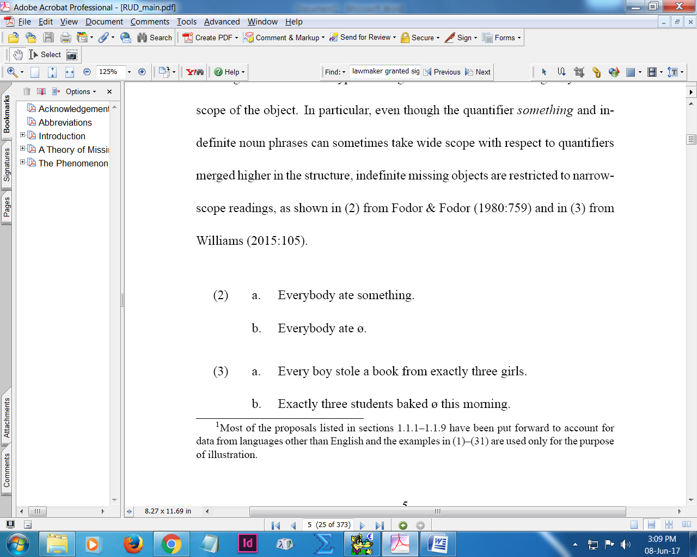

<list id="q1_2" list-type="simple" list-content="example">
<list-item><label>(2)</label><p>
<list list-type="simple">
<list-item id="q1_2a"><label>a.</label><p>

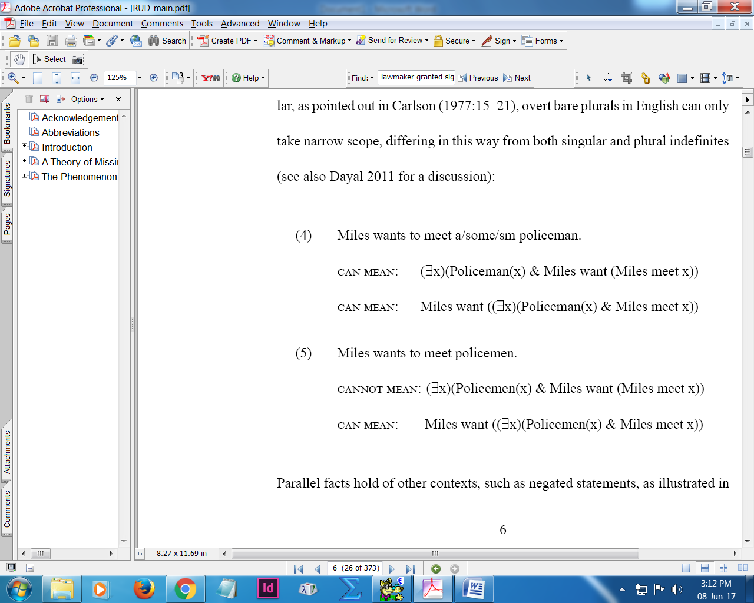

<list id="q1_4" list-type="simple" list-content="example">
<list-item><label>(4)</label><p>
<array content-type="glossed-example">
<tbody>

<list-item id="q1_12a"><label>a.</label><p>
<array content-type="glossed-example">
<tbody>

<app id="app8_1">
<title>Appendix&#xa0;1.&#x2002;

<article-title xml:lang="el">

<fn-group><fn id="c2-tab1-fn1"><label>*</label>

<mixed-citation publication-type="book">
<mixed-citation publication-type="confproc">
<mixed-citation publication-type="journal">
<mixed-citation publication-type="other">
<mixed-citation publication-type="thesis">
<mixed-citation publication-type="web">

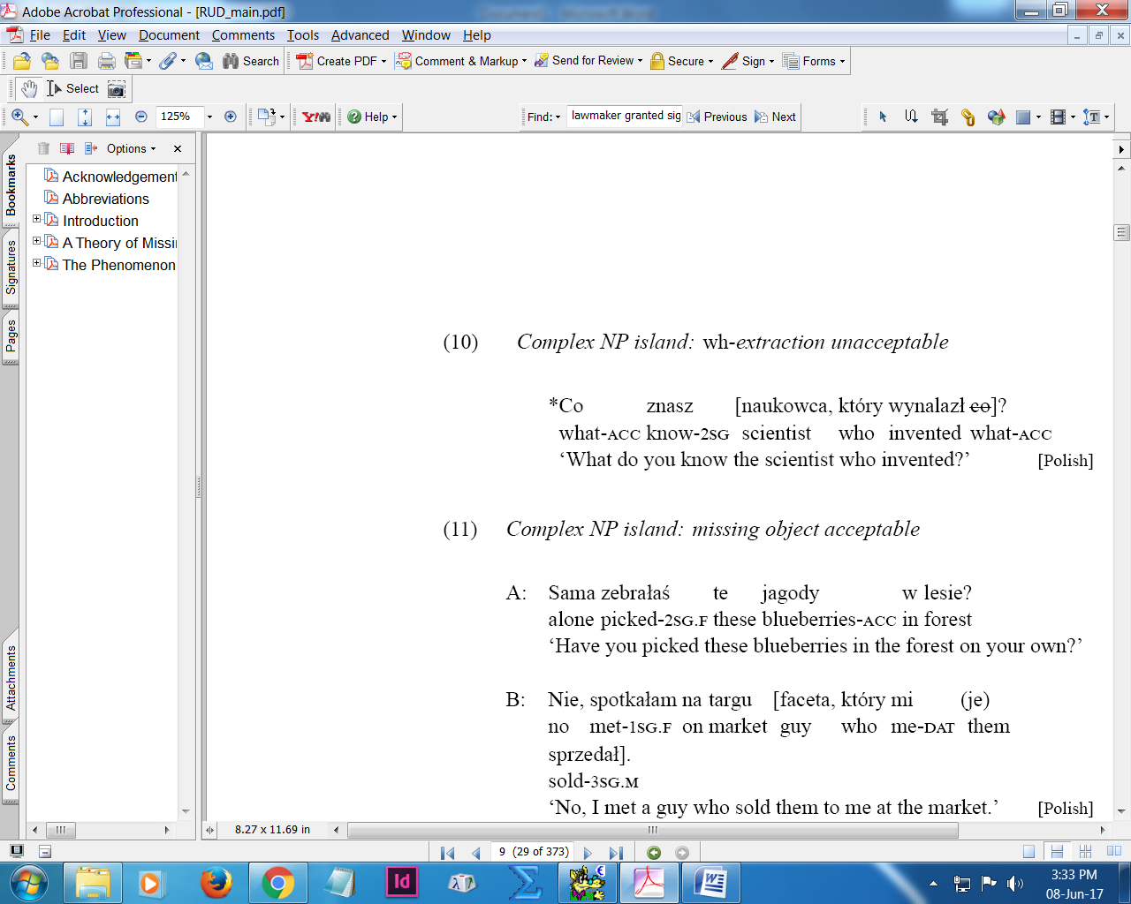
<named-content content-type="grammaticality-marker">*</named-content>

<named-content content-type="source-label"> for where <attrib> not possible to tag

<trans-source xml:lang="de">

